

|  |  |
| --- | --- |
| **Student Numbers** | **10364254 & 10374225** |
| **Student Name** | **Swapnadeep Das & N.S. Sai Nikhil** |
| **Course Title** | **MSC In Information Systems with Computing** |
| **Lecturer Name** | **Paul Laird** |
| **Module Code** | **B9IS104** |
| **Module Title** | **Enterprise Information Systems** |
| **Assignment Title** | **Web Services API Development** |
| **No of Words** | **557 (excluding Table of Contents, Bibliography and Appendix)** |
| **Date of Submission** | **22 June 2018** |

**Project Report on development of Web API:**

The term Web Services describes a standardized way of integrating internet-based applications using XML, SOAP and UDDI open standard over an in-internet protocol. XML is used to tag the data, SOAP is used to transfer the data, WSDL is used for describing the services available and UDDI is used for listing what services are available. Web services are primarily used in businesses to communicate to each other’s and with clients. Web Services allow organizations to communicate data without knowledge of each other’s IT systems behind the firewall.

**Web Services Diagram:**

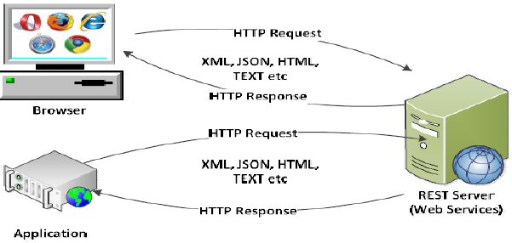

Our project is completely related to Web Service as we have developed a Web API which has given the provision to create a new contact. The first API we have developed is Web API i.e. <http://localhost:8081/api/Contacts> and the second one we have developed is MVC application and it is called as consuming API. It gets access via URL <http://localhost:8081>. http://localhost:8081/Help URL has provided an end points of API to consumers. The user will be able to get all the contact details. All the contact details of the company will be maintained in a centralized location.